VR UI Design for Engineering Applications Project
Design Document

Team Number: sdmay18-08
Client: Mr. Tsung-Pin
Advisor: Chris Chu
Team Members/Roles:
YuwenXia- Project Manager
XueyuanChen- Web Manager
ZhenFang- Testing Engineer
HongjiLuo- Meeting Scribe
JianchengZhang- Report Manager
ZimingLiu- Meeting Facilitator
Team Email:yuwenx@iastate.edu
Team Website:
http://sdmay18-08.sd.ece.iastate.edu/
Revised: Dec.2.2017/ Version 2

Table of Contents

List of figures/tables/symbols/definitions 2
1 Introduction 3
1.1 Acknowledgement 3
1.2 Problem and Project Statement 3
1.3 operational Environment 3
1.4 Intended Users and uses 4
1.5 Assumptions and Limitations 4
1.6 Expected End Product and Deliverables 4
2. Specifications and Analysis 5
2.1 Proposed Design 5
2.2 Design Analysis 5
3. Testing and Implementation 6
3.1 Interface Specifications 6
3.2 Hardware and software 6
3.3 Process 6
3.4 Results 6
4 Closing Material 7
4.1 Conclusion 7
4.2 References 7
4.3 Appendices 7

List of figures/tables/symbols/definitions

1 Introduction

Acknowledgement
Mr. Tsung-Pin support us a oculus development kit2 and two razer controllers. Also, Mr. Tsung-Pin provide us some resources about the VR interface design. Tsung-Pin lead us to his company to show the sample VR interface. Finally, Tsung-Pin give suggestions and points to help us to follow the right direction.

Problem and Project Statement
Problem:
Virtual reality has the advantage of intuitive. Because of this advantage, many companies start to develop the application that are used for the engineering area in the virtual reality environment. Most of the user interfaces are difficult for the users to control. There are always too many functions in the user interface which will make the user interface look messy and make the user be difficult to control the application. An improved user interface is needed for the applications in the virtual reality environment.
Project statement:
Our project will focus on combine the functions and operations so that the user interface will be convenient for the users to operate. Also, the VR interface can avoid the occlusion in VR environment.
The target:
The target of our project is making a new kinds of user interface that will suit for most of the engineering applications in the virtual reality environment. The output of our project will be a complete user interface for a specific application and this user interface will contain the features of convenient and clear control. Also, our project can handle occlusion in VR environment.

Operational Environment
The operational environment of our project is the virtual reality environment. In addition, we will focus on the applications that are used for engineering. We will demo the VR interface with the Oculus Rift, a virtual reality headset, at the end of next semester.

Intended Users and uses
Our primary users are those engineers who use VR software to design cars or other type of machines, since in VR environment there is no cost for material and more straightforward. However, our goal is to design such an user interface that is friendly to first-time-VR-users and make them find it easy to use.
As I mentioned, the primary usage is to make design convenient and economic, so we introduce VR environment instead of real material. However, engineering application’s user interface is not that friendly and first time user may hard to get familiar with it. We want people who use our user interface find it easy to operate.
For engineers, our VR interface can naturally handle occlusion in VR environment.

Assumptions and Limitations
Assumption:
Even first time user should find it easy to use.
People with VR experience should find it effective and not hard to perform.
The interface should be well matched car design application.
Interface should be fully functionalized by the devices that we already have.
VR interface can handle occlusion in VR environment.
User won’t feel un-natural in the VR interface.

Limitations:
Indoor environment with at least one camera and a computer to support running.(with VR required devices)
No limitations on user but recommended VR experienced person.
No hardware design.
Support most common household voltage.
Cost won’t exceed one hundred dollars as long as you have the required devices.
No geographical constraints.

Expected End Product and Deliverables
At the December, VR interface(concepts) should be designed. Firstly, VR can easily be used by new users. Then, VR interface can handle occlusion in VR environment. We plan to make our VR interface become entity. Also, we will deliver design documents and finish the VR design.
At the May, 2018. VR interface should be visible in Oculus Rift. Users can use controllers to make decisions. Users can easily to use even users are the first time to use the VR.

2. Specifications and Analysis

Proposed Design
We will design the VR UI for engineering application. In our project, the most challenging work is combine unity, the programming language we just learned with the design of UI to achieve the project. There are five steps to achieve design thinking, which are empathize, define, ideate, prototype and test. We need to empathize the user and innovate useful product for them. We designed two ideas and presented to client and advisor. With client’s advise, we have planned to combine two ideas and figured out some issues of our current designs.
2.1.1 Interface requirements
Our project is VR UI for engineering. Therefore, we focus on the design and utility of VR UI. The VR UI not only is helpful for engineers to work(handling occlusion in VR) on their projects, but also is easy for people who are not familiar with VR to use.
2.1.2 Usability requirements
For using easily, we need to design a simple and clear VR UI. The operations of controllers should be easy. Users won’t feel confusing in the VR environment.
2.1.3 Performance requirements
The VR UI should benefit for introducing, designing and measuring products.
2.1.4 Supportability requirements
We will use Unity and javascript to program. All of us did not know much about Unity and C# before. Therefore, four of group members have learned Unity and C#, and the other two members work on research about VR and VR UI.

Design Analysis
In September, we divided our team to two groups. One group had two people who worked on finding and summarize researches. The other group had four people who worked on learning Unity. The research group had a presentation at the end of September. They talked about what was VR UI and how to design it. It provided us the basic ideas about our project. At the beginning of October, we visited client’s office and tried their VR product. We learned more about UI for engineering application and what we needed to work on. Then, we began to design our project VR UI. At first, everyone made a design. We had a meeting and discussed about design of each one. Then we combined the design to two kinds of design and separated members to two groups again. When we spent two weeks to modify two designs and built 3d model to show our ideas better. After finishing the first version of designs, we met client again and got advices from him. The most significant issue of both designs is that we ignore the occlusion situation. Occlusion situation means that our UI cannot be seen or has conflict when we stand very close to object. Therefore, we will take time to figure out some new design to solve this issue.
Depending on suggestions from the client, we change our VR interface server times. As we continue to change the our VR interface, the VR interface can handle server unnatural situation in VR environment.

Testing and Implementation

Interface Specifications
Because we are trying to make user interface for VR applications, so we do not really need an interface to test our project. However, a simulator and the actual VR devices would be used in future to test our project. The VR devices including Oculus development Kit 2 and Razer Hydra controllers are provided by our client. In addition, we will demo our final result in the Unity with the Oculus Rift.

Hardware and software
Hardware: Oculus, Razer Hydra PC Gaming Motion Sensing Controllers, PC, monitor
Software: Unity, sketch
Design and test on Unity, vision by Oculus, controlled by controllers, motion captured by monitor and the whole process is done by PC(high performance)

Process
Currently, we still work on the design which fits the client’s demand. Each two weeks, we have meeting with the client, we will have presentation for him. Then, the client gives the feedback for us.
Completed work:
- Collect existing VRUI information .
- Make presentations about our ideas about the existing VRUI.
- Summarize ideas and create our first version of the VRUI.
- Create the conceptual sketch about our first design.
- Demo our design to the client and modify our design with the response of the client.
- Take research on the academic papers that are related to the VRUI design and improve of design
- Complete our final version of our VRUI design.
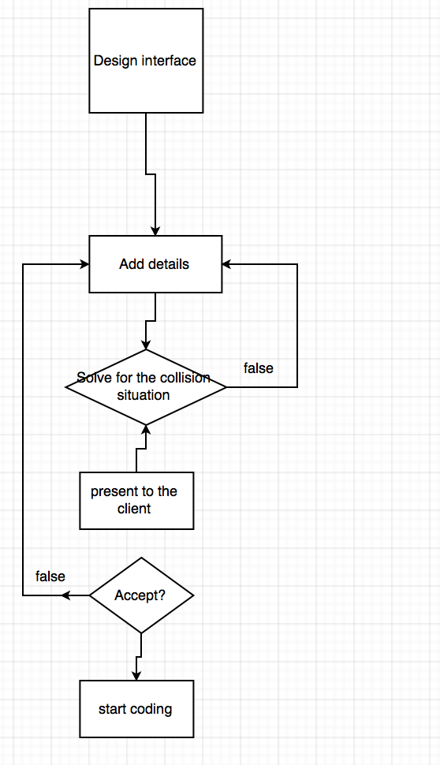

Results
We have the idea of VR UI design that solve common issues. We get basic knowledge of Unity program coding. We have a drawing diagram of ideal VR User Interface. We are in progress of Unity coding in static part of UI. We continue patent search and present to client. We will code in Unity program for a structure which include image, icon, background. Various functions will be added in VR UI, such as selection, move part, drawing. We will make controller and head-mounted display work with Unity program.

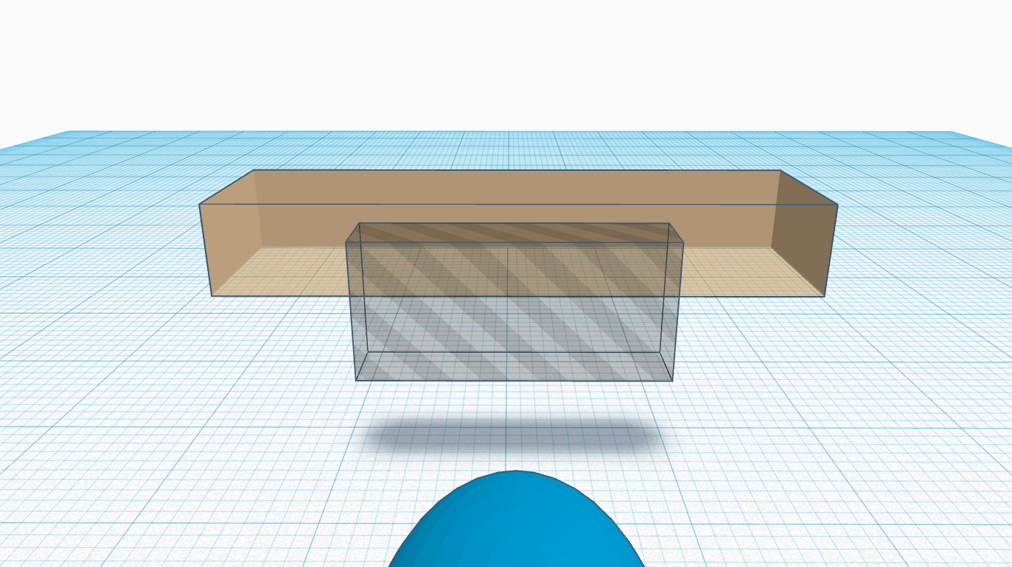
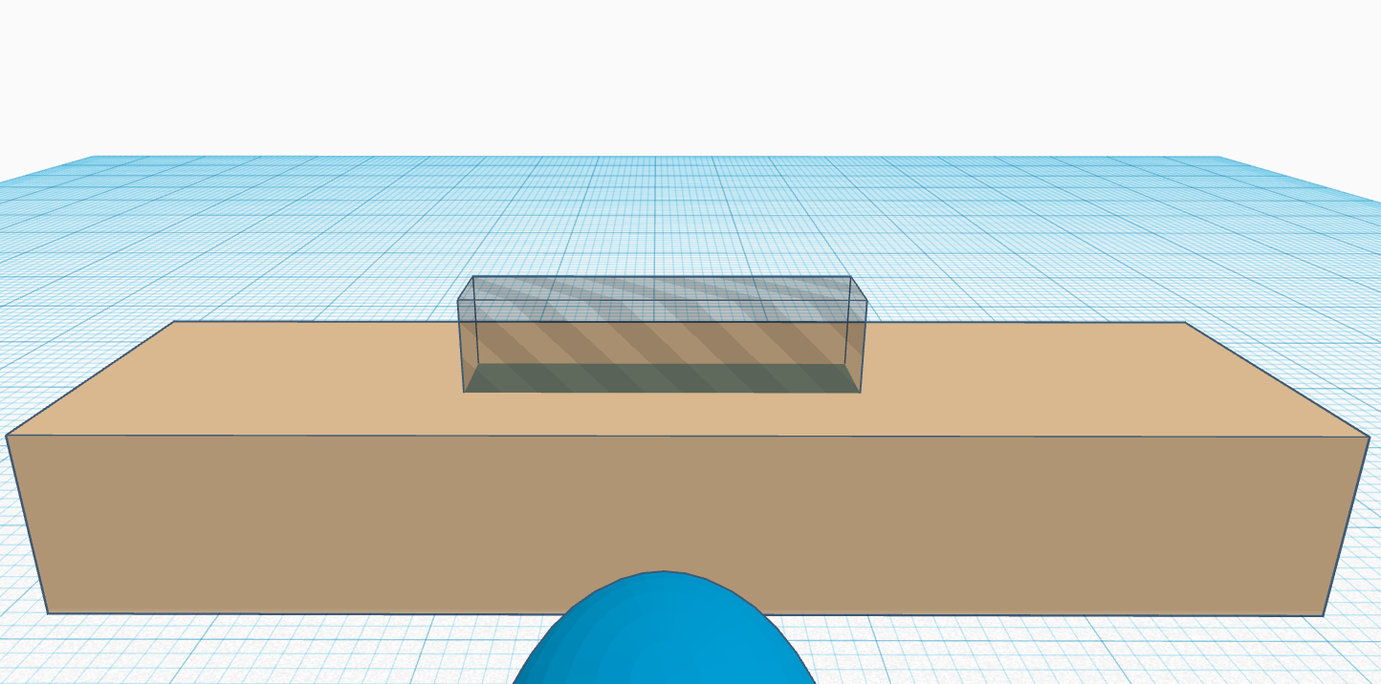
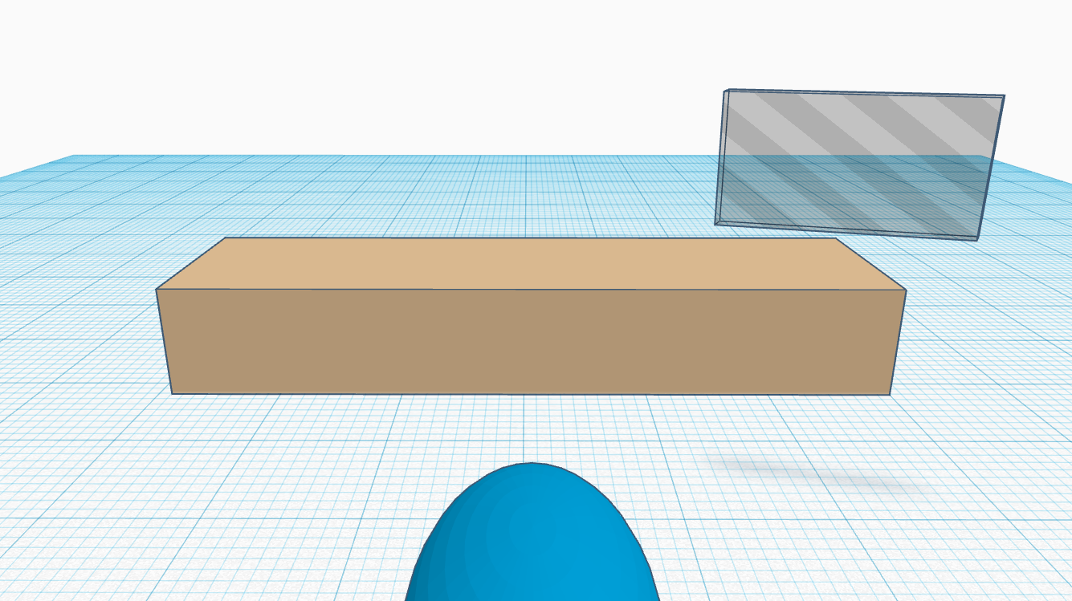
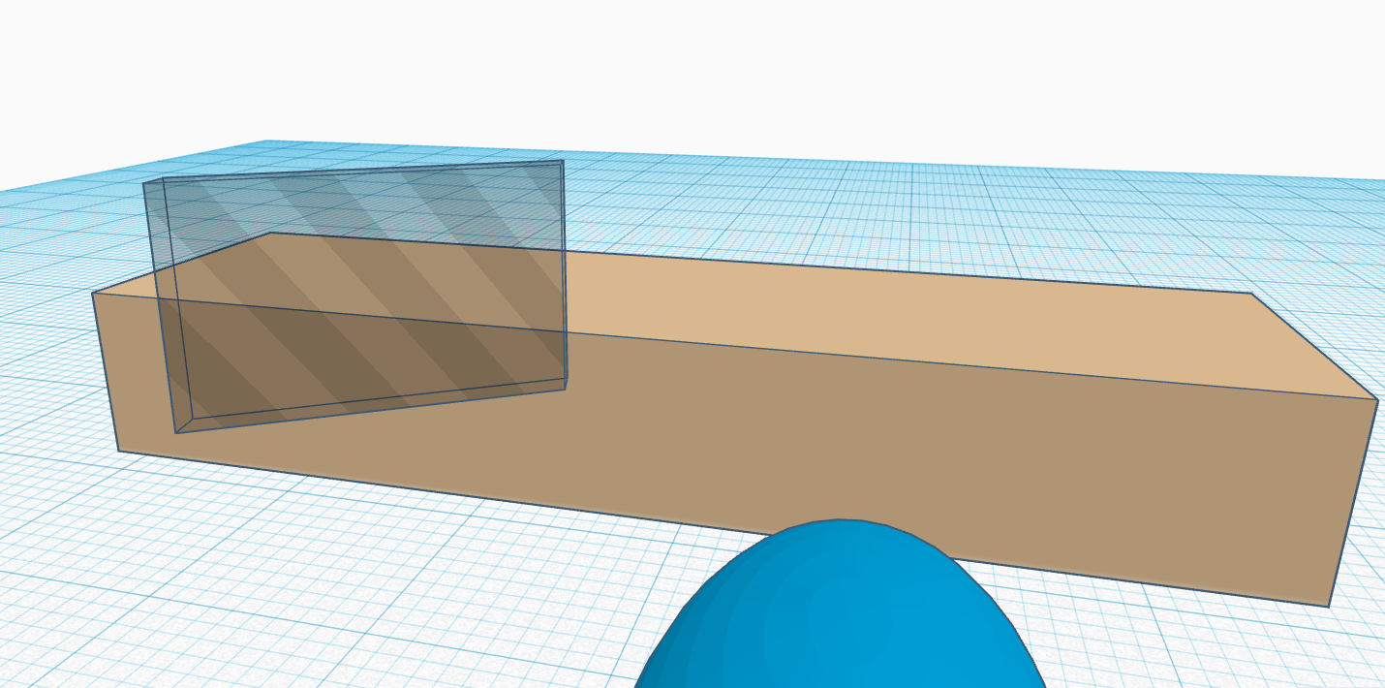
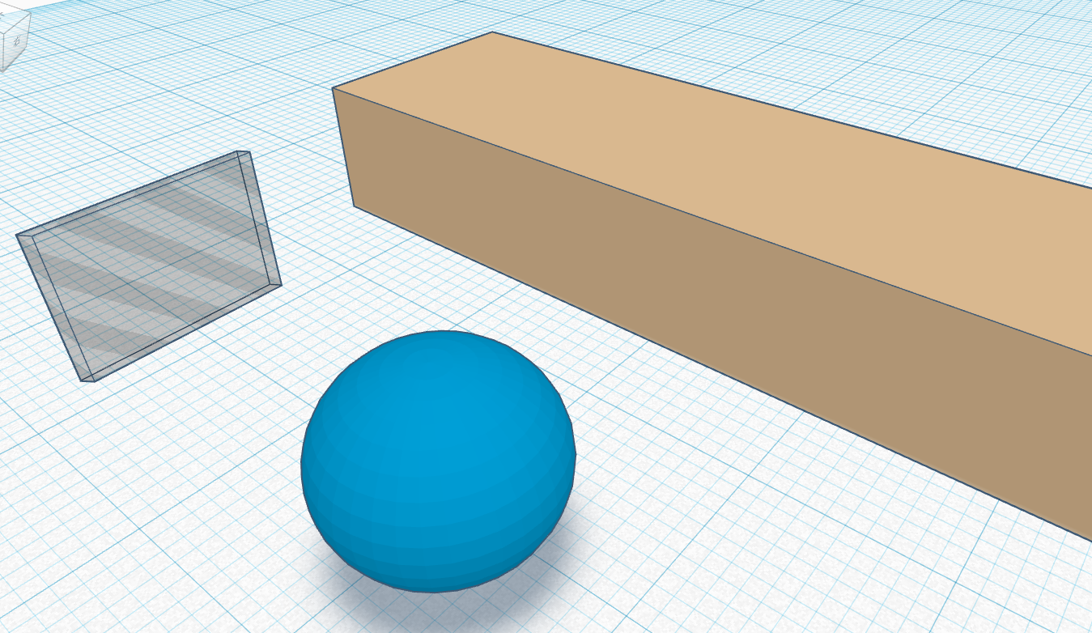

Figure 1. UI Design idea1 Demo

4 Closing Material

4.1 Conclusion
For now, we are discussing what our User Interface shall looks like with our client, what function do we need to have. After we decide what we should do in specific this month, we will start to do the coding part. Hopefully, the static part including the graphic and text part will be done within next month.
All in all, our goal is to make a user interface to help both the customers and engineers to operate efficiently within VR environment. At the mean time, this UI would be easy to be understood and used. By doing so, we shall first decide what the UI should be looks like and what the function it should have. Then we separate it with static and dynamic part and finish them one by one. It is steady and safe by doing so, and we still have chance to fit any changes that we might made in future.

4.2 References
This website helps us learning the use of the application Unity which will use in our project:
https://unity3d.com/learn
This video introduces what kind of application we should create in our project:
https://www.youtube.com/watch?v=IcmX_XtmZHg
This is a sample application in computer that we can learn for:
https://www.youtube.com/watch?v=0eou-mVnUlI\
Getting Started With VR Interface Design:
https://www.smashingmagazine.com/2017/02/getting-started-with-vr-interface-design/
A useful website to learn Unity for design VR UI
https://www.uxofvr.com/
IC IDO
“IC.IDO - Industrial Grade Immersive VR Solution.” ESI Group, 25 Sept. 2017, www.esi-group.com/software-solutions/virtual-reality/icido-industrial-grade-immersive-vr-solution.

4.3 Appendices

